39.64: a) 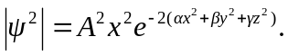To save some algebra, let 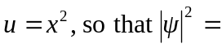
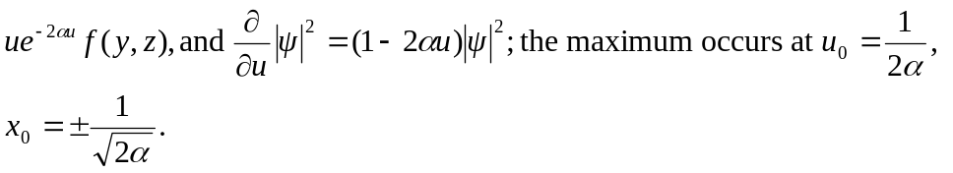
b) vanishes at 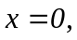 so the probability of finding the particle in the  plane is zero. The wave function vanishes for 